CHAPTER 1
INTRODUCTION
Security and the authentication of individuals is necessary for many different areas of our lives, with most people having to authenticate their identity on a daily basis; examples include ATMs, secure access to buildings, and international travel. Biometric identification provides a valid alternative to traditional authentication mechanisms such as ID cards and passwords, whilst overcoming many of the shortfalls of these methods; it is possible to identify an individual based on who they are" rather than what they possess" or what they remember".
Iris recognition is a particular type of biometric system that can be used to reliably indentify a person by analyzing the patterns found in the iris. The iris is so reliable as a form of identification because of the uniqueness of its pattern. Although there is a genetic influence, particularly on the iris's color, the iris develops through folding of the tissue membrane and then degeneration (to create the pupil opening) which results in a random and unique iris.
In comparison to other visual recognition techniques, the iris has a great advantage in that there is huge variability of the pattern between individuals, meaning that large databases can be searched without finding any false matches. This means that irises can be used to identify individuals rather than just confirm their given identity; a property that would be useful in a situation such as border control, where it might be important to not just show that an individual is not who they say they are but also to show exactly who they are.
The objective of this project was to produce a working prototype program that functions as an
iris recognition tool using the algorithms described by Professor John Daugman and other techniques in order to implement this in an accurate and useful way that is also user-friendly. Commercial iris recognition systems are available that implement similar algorithms to these, however, there does seem to be an absence of open source implementations. This is the hole that this project sets out to fill: providing a fast, usable program that can easily be extended.

1.1 Project idea

The eyelids are a major factor while segmenting the iris. The approach can be
- having a clear picture of the iris by having minimum interaction of the eyelids or
- having an algorithm which doesn't take into account the part of iris which is occupied by the eyelids.

Since having i) is quite difficult and requires ideal conditions, we used ii) as our current algorithm .

We segment an iris and then select its that contour which is not under the influence of eyelids by specifying an angle. We can thus control the angle and thus the data and the accuracy of our algorithm.

CHAPTER 2
IRIS RECOGNITION SYSTEM
2.1 BIOMETRIC TECHNOLOGY
2.1.1 Overview
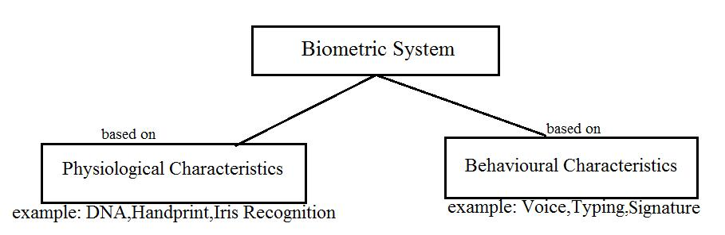
Biometric is general term used alternatively to describe a characteristic or a process. As a characteristic it is a measureable biological (anatomical and physiological) and behavioural characteristic that can be used for automated recognition. As a process it encompasses automated methods of recognizing an individual based on measureable biological (anatomical and physiological) and behavioural characteristics. A biometric system provides automatic recognition of an individual based on same sort of unique features or characteristic possessed by the individual.

Fig 2.1: Biometric System
Biometric recognition, or biometrics, refers to the automatic identification of a person based on his/her anatomical (e.g., fingerprint, iris) or behavioral (e.g., signature) characteristics or traits. This method of identification offers several advantages over traditional methods involving ID cards (tokens) or PIN numbers (passwords) for various reasons: (i) the person to be identified is required to be physically present at the point-of-identification; (ii) identification based on biometric techniques obviates the need to remember a password or carry a token. With the increased integration of computers and Internet into our everyday lives, it is necessary to protect sensitive and personal data. By replacing PINs (or using biometrics inaddition to PINs), biometric techniques can potentially prevent unauthorized access to ATMs, cellular phones, laptops, and computer networks. Unlike biometric traits, PINs or passwords may be forgotten, and credentials like passports and driver's licenses may be forged, stolen, or lost. As a result, biometric systems are being deployed to enhance security and reduce financial fraud. Various biometric traits are being used for real-time recognition, the most popular being face, iris and fingerprint. However, there are biometric systems that are based on retinal scan, voice, signature and hand geometry. In some applications, more than one biometric trait is used to attain higher security and to handle failure to enroll situations for some users. Such systems are called multimodal biometric systems.
A biometric system is essentially a pattern recognition system which recognizes a user by determining the authenticity of a specific anatomical or behavioral characteristic possessed by the user. Several important issues must be considered in designing a practical biometric system. First, a user must be enrolled in the system so that his biometric template or reference can be captured. This template is securely stored in a central database or a smart card issued to the user. The template is used for matching when an individual needs to be identified. Depending on the context, a biometric system can operate either in a verification (authentication) or an identification mode.
Because biometrics-based authentication offers several advantages over other authentication methods, there has been a significant surge in the use of biometrics for user authentication in recent years. It is important that such biometrics-based authentication systems be designed to withstand attacks when employed in security-critical applications, especially in unattended remote applications such as e-commerce.
Questions related to the identity of individuals such as “Is this the person who he or she claims to be?,” “Has this applicant been here before?,” “Should this individual be given access to our system?” are asked millions of times every day by organizations in financial services, health care, e-commerce, telecommunication, and government. In fact, identity fraud in welfare disbursements, credit card transactions, cellular phone calls, and ATM withdrawals totals over $6 billion each year. For this reason, more and more organizations are looking to automated identity authentication systems to improve customer satisfaction and operating efficiency as well as to save critical resources. Furthermore, as people become more connected electronically, the ability to achieve a highly accurate automatic personal identification system is substantially more critical.
Evaluating the performance of a biometric identification system is a challenging research topic. The overall performance of a biometric system is assessed in terms of its accuracy, speed, and storage. Several other factors, like cost and ease-of-use, also affect efficacy. Biometric systems are not perfect, and will sometimes mistakenly accept an impostor as a valid individual (a false match) or conversely, reject a valid individual (a false no match). The probability of committing these two types of errors are termed false no match rate (FNR) and false match rate (FMR); the magnitudes of these errors depend upon how liberally or conservatively the biometric system operates. the trade-off between a system’s FMR and FNR at different operating points; it’s called the “Receiver Operating Characteristics (ROC)” and is a comprehensive measure of the system accuracy in a given test environment. High-security access applications, where concern about break-in is great, operate at a small FMR. Forensic applications, where the desire to catch a criminal outweighs the inconvenience of examining a large number of falsely accused individuals, operate their matcher at a high FMR. Civilian applications attempt to operate their matchers at the operating points with both a low FNR and a low FMR. The error rate of the system at an operating point where, for a given test environment are unacceptable (insufficient). The size of a template, the number of templates stored per individual, and the availability of compression mechanisms determine the storage required per user. When template sizes are large and the templates are stored in a central database, network bandwidth may become a system bottleneck for identification. A typical smartcard may only hold a few kilobytes of information (for instance, 8K) and in systems using smartcards to distribute the template storage, template size becomes an important design issue. The time required by a biometric system to make an identification decision is critical to many applications. For a typical access-control application, the system needs to make an authentication decision in real-time. In an ATM application, for instance, it is desirable to accomplish the authentication within about one second. For forensic applications, however, the time requirements may not be very stringent.
All other factors remaining identical, the widespread use of biometrics will be stimulated by its adoption in the consumer market. The single most important factor affecting this realization is the cost of the biometrics systems including the sensors and related infrastructure. Some sensors, such as microphones, are already very inexpensive, while others, such as CCD cameras, are now becoming standard peripherals in a personal computing environment. With the recent advances in solid-state technology, fingerprint sensors will become sufficiently inexpensive in the next few years. Storage requirements of the biometric templates and processing requirements for matching are among the two major considerations towards the infrastructure cost.
A biometric system generally involves three modules as:
• Recognition
• Verification
• Identification
Recognition is used in the description of required or relevant data from input biometric data for example face recognition, iris recognition which relates to their fundamental function.
Verification (Am I who I claim I am?) involves confirming or denying a person's claimed identity. Verification in biometric systems involves the tasks where the biometric system attempts to confirm an individual’s claimed identity by comparing a submitted sample to one or more previously enrolled templates.
In identification, the system has to recognize a person (Who am I?) from a list of N users in the template database. Identification is a more challenging problem because it involves 1:N matching compared to 1:1 matching for verification. Identification module involves the tasks where the biometric system searches a database for a reference matching a submitted sample. A biometric data is collected and compared to all the templates in a database. Closed set identification involves where person is known to exist in database. Open set identification involves where person is not guaranteed to exist in database.
Biometric system work by first computing a sample of feature, such as recording a digital sound signal for voice recognition, or taking a colour image for face recognition. The sample is the transformed using same sort of mathematical function into a biometric template. The biometric template will provide a normalized and efficient representation of the feature, which can then be objectively compared with order to determine the identity.
Biometric Presentation

Capture and Pre-processing

Storage

Template Creation
Feature Extraction

Fig 2.2: Working of biometric system

2.1.2 Choosing a biometric system
Since there are many biometric systems which can be employed but the factors on which implementation depends inter alia are :
• Location
• Security Risk
• Task (Identification or Verification)
• Expected number of users
• Existing data
• User circumstances

2.1.3 Advantages of using Biometrics
• Easier fraud detection
• Better than password/PIN or smart cards
• No need to memorize passwords
• Requires physical presence of the person to be identified
• Unique physical or behavioral characteristic
• Cannot be borrowed, stolen, or forgotten
• Cannot leave it at home

2.2 IRIS RECOGNITION
2.2.1 Overview
The iris is an externally visible, yet protected organ whose unique epigenetic pattern remains stable throughout adult life. These characteristics make it very attractive for use as a biometric for identifying individuals. The purpose of ‘Iris Recognition’, a biometrical based technology for personal identification and verification, is to recognize a person from his/her iris prints. In fact, iris patterns are characterized by high level of stability and distinctiveness. Each individual has a unique iris. The difference even exists between identical twins and between the left and right eye of the same person.
The probability of finding two people with identical iris patterns is considered to be approximately 1 in 1052 (population of the earth is of the order 1010). Not even one-egged twins or a future clone of a person will have the same iris patterns. The iris is considered to be an internal organ because it is so well protected by the eyelid and the cornea from environmental damage. Iris recognition is the most precise and fastest of the biometric authentication method.

2.2.2 Why iris recognition?
Having studied various biometric technologies, the simple justification for choosing iris recognition technology, the four most basic conditions that any biometric system must possess are:
• Universal: The feature in question should be with everyone.
• Unique: No two people have that feature alike.
• Permanent: The feature does not change and cannot be changed.
• Collectable: The feature is easy to obtain and quantify with a sensor.

Table 2.1: Comparison of MAJOR biometric techniques

Table 2.2: Iris recognition system accuracy
- The comparison of various biometrics techniques is given in the tables below. The comparison shows that IRIS recognition system is the most stable, precise and the fastest biometric authentication method.

2.2.3 The Human Iris
The iris is a thin circular diaphragm, which lies between the cornea and the lens of the human eye. The iris is perforated close to its centre by a circular aperture known as the pupil. The function of the iris is to control the amount of light entering through the pupil, and this is done by the sphincter and the dilator muscles, which adjust the size of the pupil. The average diameter of the iris is 12 mm, and the pupil size can vary from 10% to 80% of the iris diameter
The iris consists of a number of layers, the lowest is the epithelium layer, which contains dense pigmentation cells. The stromal layer lies above the epithelium layer, and contains blood vessels, pigment cells and the two iris muscles. The density of stromal pigmentation determines the colour of the iris. The externally visible surface of the multi-layered iris contains two zones, which often differ in colour. An outer ciliary zone and an inner pupillary zone, and these two zones are divided by the collarette – which appears as a zigzag pattern.
Formation of the iris begins during the third month of embryonic life. The unique pattern on the surface of the iris is formed during the first year of life, and pigmentation of the stroma takes place for the first few years. Formation of the unique patterns of the iris is random and not related to any genetic factors. The only characteristic that is dependent on genetics is the pigmentation of the iris, which determines its colour. Due to the epigenetic nature of iris patterns, the two eyes of an individual contain completely independent iris patterns, and identical twins possess uncorrelated iris patterns.
The iris is divided into two major regions:
1. The pupillary zone is the inner region whose edge forms the boundary of the pupil.
2. The ciliary zone is the rest of the iris that extends to its origin at the ciliary body.
Iris surface features:
- The pupillary ruff is a series of small ridges at the pupillary margin formed by the continuation of the pigmented epithelium from the posterior surface.
- The Circular contraction folds, also known as contraction furrows, are a series of circular bands or folds about midway between the collaret and the origin of the iris. These folds result from changes in the surface of the iris as it dilates.
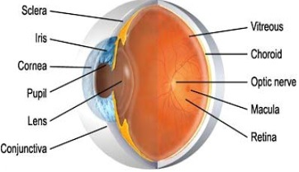
- Crypts at the base of the iris are additional openings that can be observed close to the outermost part of the ciliary portion of the iris.

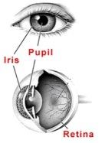
Fig 2.3: Structure of an eye

Fig 2.4: Iris diagram
Fig 2.5: Internal structure of iris

Features of iris
The iris has many features that can be used to distinguish one iris from another. One of the primary visible characteristics is the trabecular meshwork, a tissue which gives the appearance of dividing the iris in radial fashion that is permanently formed by the eighth month of gestation. During the development of the iris, there is no genetic influence on it, a process known as chaotic morphogenesis that occurs during the seventh month of gestation, which means that even identical twins have different irises.
The fact that the iris is protected behind the eyelid, cornea, and aqueous humor means that, unlike other biometrics such as fingerprints, the likelihood of damage or abrasion is minimal. The iris is also not subject to the effects of aging which means it remains in a stable form about the age of one until death. The use of glasses or contact l lenses (colored or clear) has little effect on the representation of the iris and hence does not interfere with the recognition technology.

2.2.4 Features of iris recognition
- Measurable Physical Features: 250 degrees of freedom, 250 non-related unique features of a person’s iris.
- Unique: Every iris is absolutely unique. No two iris are the same
- Stable: iris remains stable from 1styear till death.
- Accurate: Iris recognition is the most accurate of the commonly used biometric technologies.
- Fast: Iris recognition takes less than 2 seconds. 20 times more matches per minute than its closest competitor.
- Non-Invasive: No bright lights or lasers are used in the imaging and iris authentication process.

2.2.5 Iris recognition system strengths:
 Highly Protected: Internal organ of the eye. Externally visible; patterns imaged from a distance
 Measurable Features of iris pattern: Iris patterns possess a high degree of randomness
➢Variability: 244 degrees-of-freedom
➢Entropy: 3.2 bits per square-millimeter
 Uniqueness: Set by combinatorial complexity
 Stable: Patterns apparently stable throughout life
 Quick and accurate: Encoding and decision-making are tractable
➢Image analysis and encoding time: 1 second

2.2.6 Iris recognition system weakness:
 Some difficulty in usage as individuals doesn’t know exactly where they should position themselves.
 And if the person to be identified is not cooperating by holding the head still and looking into camera.

CHAPTER 3
WORKING OF THE PROJECT

  - WORKING PRINCIPLE
Seminal work of Daugman “How Iris Recognition Works” provides the most reliable technology while many researchers have put their contributions in the technology
Basically the iris recognition technology has four basic technological modules which are implemented in sequence are:
1. Segmentation
2. Normalisation
3. Feature Encoding
4. Matching Algorithms

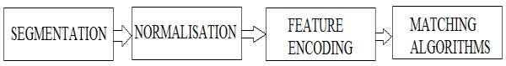

Fig 3.1: Basic Technological Components of Iris Recognition Technology

3.1.1 Segmentation
The very first module of iris recognition is to separate or segment the actual iris region in a digital eye image. The iris region, can be approximated by two circles, one for the iris/sclera boundary and another, interior to the first, for the iris/pupil boundary. The eyelids and eyelashes normally occlude the upper and lower parts of the iris region. Also, specular reflections can occur within the iris region corrupting the iris pattern. A highly efficient technique is required to isolate and exclude these artefacts as well as locating the circular iris region. This module of the technology is very crucial for the rest of the modules, since data that is falsely represented as iris pattern data will corrupt the biometric templates generated, resulting in poor recognition rates.
Main technological viewpoint discussed in segmentation module is of Daugman’s Integro-differential Operator.

Daugman’s Integro-differential Operator:
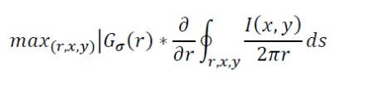
Daugman makes use of an integro-differential operator for locating the circular iris and pupil regions, and also the arcs of the upper and lower eyelids. The integro-differential operator is defined as;

where I(x,y) is the eye image, r is the radius to search for, Gσ(r) is a Gaussian smoothing function, and s is the contour of the circle given by r, x0, y0. The operator searches for the circular path where there is maximum change in pixel values, by varying the radius and centre x and y position of the circular contour. The operator is applied iteratively with the amount of smoothing progressively reduced in order to attain precise localisation. Eyelids are localised in a similar manner, with the path of contour integration changed from circular to an arc.

3.1.2 Normalisation
The very next step once the iris region is successfully segmented from an eye image, is to transform the iris region so that it has fixed dimensions in order to allow comparisons. The dimensional inconsistencies between eye images are mainly due to the stretching of the iris caused by pupil dilation from varying levels of illumination. Other sources of inconsistency include, varying imaging distance, rotation of the camera, head tilt, and rotation of the eye within the eye socket. The normalisation process will produce iris regions, which have the same constant dimensions, so that two photographs of the same iris under different conditions will have characteristic features at the same spatial location.
Another point of note is that the pupil region is not always concentric within the iris region, and is usually slightly nasal. This must be taken into account if trying to normalise the “doughnut‟ shaped iris region to have constant radius.
Daugman’s Rubber Sheet Model
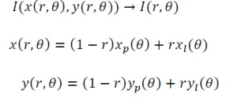
The homogenous rubber sheet model devised by Daugman remaps each point within the iris region to a pair of polar coordinates (r,θ) where r is on the interval [0,1] and θ is angle [0,2π]. The remapping of the iris region from (x,y) Cartesian coordinates to the normalised non-concentric polar representation is modeled as ;

Where I(x,y) is the iris region image, (x,y) are the original Cartesian coordinates, (r,θ) are the corresponding normalised polar coordinates, and ᥳḂ᐀ ᥴḂ and ᥳ᷾ᥴ᷾ are the coordinates of the pupil and iris boundaries along the θ direction. The rubber sheet model takes into account pupil dilation and size inconsistencies in order to produce a normalised representation with constant dimensions. In this way the iris region is modelled as a flexible rubber sheet anchored at the iris boundary with the pupil centre as the reference point.
Even though the homogenous rubber sheet model accounts for pupil dilation, imaging distance and non-concentric pupil displacement, it does not compensate for rotational inconsistencies. In the Daugman system, rotation is accounted for during matching by shifting the iris templates in the θ direction until two iris templates are aligned
3.1.3 Feature Encoding
In order to provide accurate recognition of individuals, the most discriminating information present in an iris pattern must be extracted. Only the significant features of the iris must be encoded so that comparisons between templates can be made. Most iris recognition systems make use of a band pass decomposition of the iris image to create a biometric template.
The template that is generated in the feature encoding process will also need a corresponding matching metric, which gives a measure of similarity between two iris templates. This metric should give one range of values when comparing templates generated from the same eye, known as intra-class comparisons, and another range of values when comparing templates created from different irises, known as inter-class comparisons. These two cases should give distinct and separate values, so that a decision can be made with high confidence as to whether two templates are from the same iris, or from two different irises.

3.1.4 Matching Algorithms
Matching Algorithms are used for verification as well as Identification functions. Inter alia it is also a sensitive technological module which requires critical examination. Three algorithms which are repeatedly used in iris recognition technology discussed
below are:
Hamming Distance
The Hamming distance gives a measure of how many bits are the same between two bit patterns. Using the Hamming distance of two bit patterns, a decision can be made as to whether the two patterns were generated from different irises or from the same one.
In comparing the bit patterns X and Y, the Hamming distance, HD, is defined as the sum of disagreeing bits (sum of the exclusive-OR between X and Y) over N, the total number of bits in the bit pattern.
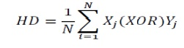
Since an individual iris region contains features with high degrees of freedom, each iris region will produce a bit-pattern which is independent to that produced by another iris, on the other hand, two iris codes produced from the same iris will be highly correlated.
If two bits patterns are completely independent, such as iris templates generated from different irises, the Hamming distance between the two patterns should equal 0.5. This occurs because independence implies the two bit patterns will be totally random, so there is 0.5 chance of setting any bit to 1, and vice versa. Therefore, half of the bits will agree and half will disagree between the two patterns. If two patterns are derived from the same iris, the Hamming distance between them will be close to 0.0 (in the project it has been fixed at 0.0032), since they are highly correlated and the bits should agree between the two iris codes.
The Hamming distance is the matching metric employed by Daugman, and calculation of the Hamming distance is taken only with bits that are generated from the actual iris region.

  - BLOCK DIAGRAM
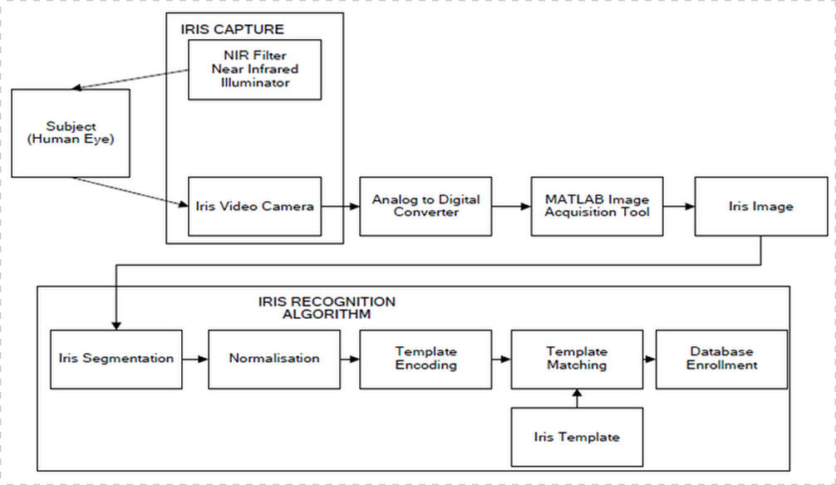

Fig 3.2 Block Diagram of Iris Recognition System

3.3 DESCRIPTION OF FLOWCHART
Fig 3.3 Flowchart

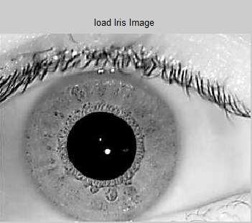
1.Load Iris Image

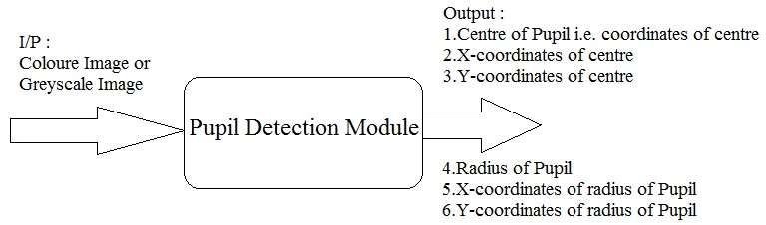
Fig 3.4: Loaded sample image of iris

Fig 3.5: Pupil detection module
2. Convert colour image or grey image to binary image.
3. Replaces all pixels in the input image with luminance greater than level with the value 1 (white) and replaces all other pixels with the value 0 (black). Specify level in the range [0,1]. This range is relative to the signal levels possible for the image's class. Therefore, a level value of 0.5 is midway between black and white, regardless of class.
4.In our case, we have generalised the threshold limit to the half of the pixel intensityof grey scale image.
5. Create a morphological disk structuring element. A flat, disk-shaped structuring element.
6. Morphological closing on the binary image, returning the closed image. The structuring element, must be a single structuring element object, as opposed to an array of objects. The morphological close operation is a dilation followed by an erosion which help in predicting pupil, iris and sclera.
7. Morphological fill the binary image on the screen and lets you define the region to fill by selecting points interactively by using the mouse. To use this interactive syntax, image must be a 2-D image which removes the highlight present in the image.
8. Produce a binary image all connected components (objects) that have fewer than P pixels, producing another binary image.
9. Selecting a predefined threshold and employing intensity criteria loop over the
boundaries.
10. Set the relevant threshold according to the data base and put the recent output image into loop to trace the exterior boundaries of objects. Image must be a binary image where nonzero pixels belong to an object and 0 pixels constitute the background.
11. Mark objects above the threshold with a black circle.
12. Isolating the pupil from image, calculate the centre and radius of pupil.
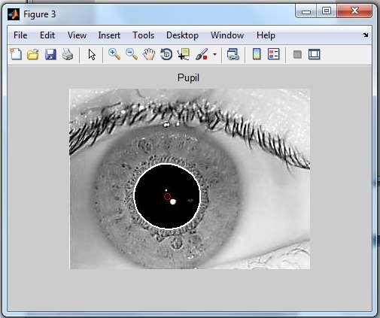

Fig 3.6: Isolated portion of pupil from sample image
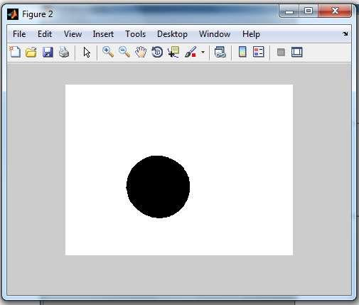

Fig 3.7: Boundary drawn on pupil from sample image
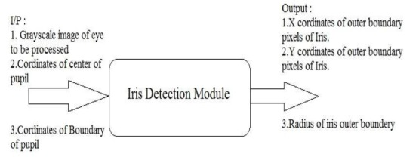
13. The outputs achieved are then used in next module.

Fig 3.8: iris detection module
14. Taking the outer most boundary coordinates into account obtained as output of pupil detection module, again put the image obtained in step 9 into loop by employing intensity criteria and the required coordinates of iris boundary having known the fact that in almost all cases bare exceptions the intensity of sclera is more than iris, whose intensity in turn is greater than pupil’s.
15. These boundary coordinates when operationalized along with the centre of pupil gives the radius of iris.
16. Thus iris boundary is drawn.(in fig: Boundary drawn on iris from sample image)
17. The outputs obtained in previous two modules is taken in account as input to the next level of module called eyelid detection module to obtain a noise free iris portion of the image.
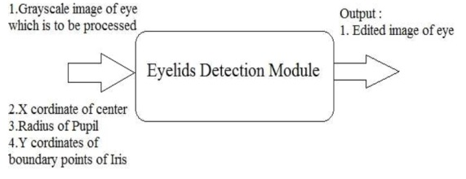
Fig 3.9: Eyelids detection module
18. The eyelids are modeled as lines.
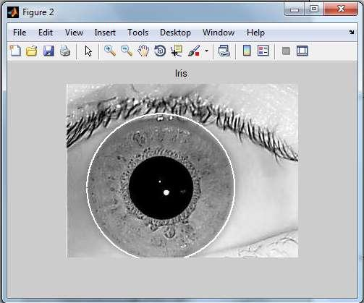
19. After calculating the extreme points on each direction of the image and applying radon transform we convert every eyelid pixel into a zero intensity black pixel thus mitigating the possibility of noise in iris portion.
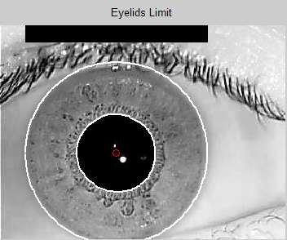

Fig 3.10: Boundary drawn on pupil and iris from sample image
20. Now the segmentation reaches its culmination where we subtract the pupil circle from its exterior iris circle thus obtaining only iris portion.
21. At this stage we have a circular portion of a tube like structure of only iris portion from the original image which is devoid of noise due to step 18.
22. From here iris starts its journey for the process of normalization.
23. The centre of the pupil was considered as the reference point, and radial vectors pass through the iris region. A number of data points are selected along each radial line and this is defined as the radial resolution.
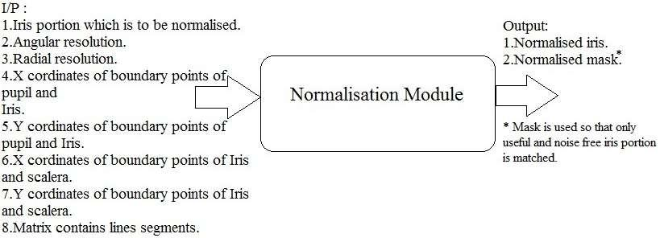

Fig 3.11: Normalisation module
24. The number of radial lines going around the iris region is defined as the angular resolution. Since the pupil can be non-concentric to the iris, a remapping formula is needed to rescale points depending on the angle around the circle.
25. A constant number of points are chosen along each radial line, so that a constant number of radial data points are taken, irrespective of how narrow or wide the radius is at a particular angle. The normalised pattern was created by backtracking to find the Cartesian coordinates of data points from the radial and angular position in the normalised pattern. From the iris region, normalisation produces a 2D array with horizontal dimensions of angular resolution and vertical dimensions of radial resolution.
26. A normalised mask corresponding to normalised iris pattern is generated in such a way that relevant iris data is represented by zero and noise is represented by one in mask template.




Fig3.12 : Normalised iris and mask of sample image
27. In order to generate the unique pattern corresponding to unique feature characteristics of normalised iris image we need to encode the normalised iris image.
28. First we create a 2D-Gabor filter.
29. Transform the normalised image into to frequency domain.
30. Take Convolution of normalized Iris Image & 2D Gabor Filter.
31.The rows of the 2D normalised pattern are taken as the 1D signal, each row corresponds to a circular ring on the iris region. The angular direction is taken rather than the radial one, which corresponds to columns of the normalised pattern, since maximum independence occurs in the angular direction.
32. Transform the convoluted output back to spatial domain.
33. Demodulation & quantised of the phase information is performed.
34. Phase quantisation is performed as :
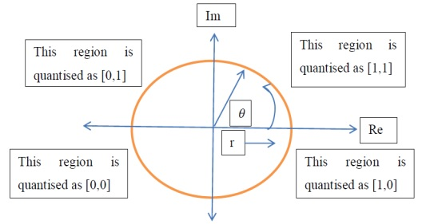

Fig3.13: Quantisation process employed in template generating module.
35. The encoding process produces a bitwise template containing a number of bits of information, and a corresponding noise mask which corresponds to corrupt areas within the iris pattern, and marks bits in the template as corrupt.
36. Since the phase information will be meaningless at regions where the amplitude is zero, these regions are also marked in the noise mask.
37. The total number of bits in the template will be the angular resolution times the radial resolution, times 2, times the number of filters used.



Fig 3.14: Encoded template of sample image
38. Thus the generated template is stored in data base for implementation.
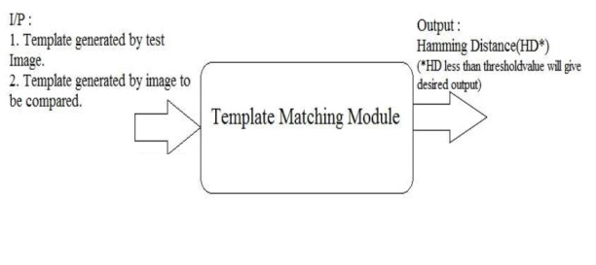
39. After culmination of three basic building blocks viz. segmentation, normalisation, feature encoding the next building block which in itself is a complementary part of every biometric system, is matching.

Fig 3.15: Template matching module
40. Matching module’s first task is to convert the templates and masks into logical class so that Hamming distance could be calculated.
41. For matching, the Hamming distance was chosen as a metric for recognition, since bit-wise comparisons were necessary. The Hamming distance algorithm employed also incorporates noise masking, so that only significant bits are used in calculating the Hamming distance between two iris templates.
Now when taking the Hamming distance, only those bits in the iris pattern that correspond to„0‟ bits in noise masks of both iris patterns will be used in thecalculation. The Hamming distance will be calculated using only the bits generated
from the true iris region, and this modified Hamming distance formula is given as
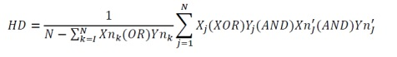
42. Predefining an approximately reliable value we compare the templates with hamming distance calculated in above step.
43. If the Hamming distance thus obtained is less than threshold the “Match Found” result is shown else “No Match Found” is displayed.
This step culminates the algorithms in the implementation of our work.

3.4 ALGORITHM USED
3.4.1 John Daugman’s algorithm
This method was proposed by Daugman in order to localize the iris region. The operator assumes the pupil and limbus region to be circular contours and it performs circular edge detection. The upper and lower eyelids are also detected using the Integro-differential operator by changing the contour search to a designed arcuate from circular. The Integro-differential operator is defined as :
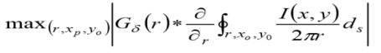

Where I(x, y) is the input eye image, r being the radius that is to be searched for, Gσ is a Gaussian function used for smoothing and s is the circle contour given by r,x0 and y0. The operator makes a pixel-wise search through the input image and obtains the partial derivative (blurred) of the integral over circular contours that have been normalized in different contours. The boundaries of the pupil and the limbus are supposed to make the contour integral derivative maximum, the point where there will be a sudden change in the values of intensity over the circular borders.
- IRIS LOCALISATION
The first stage of iris recognition is the isolation of the actual iris region. Two circles are used to separate between iris/sclera boundary and iris/pupil boundary. The eyelids and eyelashes occlude the upper and lower parts of the iris region normally. The success of segmentation depends on the imaging quality of eye images. Also, persons with darkly pigmented irises will present low contrast between the pupil and iris region if they are imaged under natural light, the mentioned factors make segmentation more difficult. Daugman use a differential operator to locate the circular iris, pupil regions and the arcs of the upper and lower eyelids.

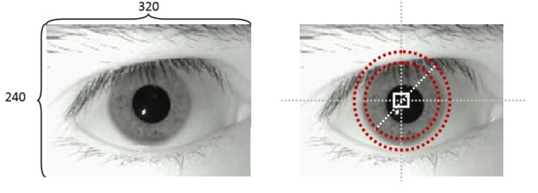

Fig 3.16: Iris Localisation
Daugman operator is based on the fact that the illumination difference between inside and outside of pixels in iris edge circle is maximum. It means that if the difference values of pixels’ gray level in iris circle are calculated, the values are higher than any other circles in images. This fact is based on color of iris and color of sclera.
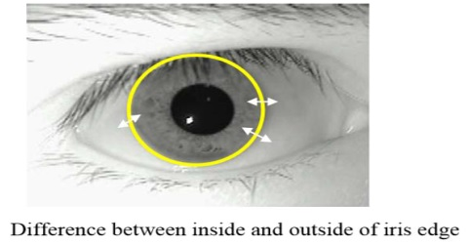

Fig 3.17: Iris Edge
It is impossible to calculate Daugman Operator for all feasible circles of an image. Therefore, we should restrict the space of potential circles. For instance, in many researches, they assume that the center of iris is near the center of image. Also they spot a range of radius which is based on the size of image. The Daugman's operator is calculated for each (x, y) and all values of r. The (x, y) and r which correspond to higher value of Daugman operator will be a final center and radius. In our example, we have 100 potential centers and 10 values for radius. It means that we should calculate Daugman operator for 1000 potential circles.

CHAPTER 4
SOFTWARE SPECIFICATIONS
4.1 MATLAB
MATLAB is a high-performance language for technical computing. It integrates computation, visualization, and programming in an easy-to-use environment where problems and solutions are expressed in familiar mathematical notation. Typical uses include:
· Math and computation
· Algorithm development
· Data acquisition
· Modeling, simulation, and prototyping
· Data analysis, exploration, and visualization
· Scientific and engineering graphics
· Application development, including graphical user interface building.
MATLAB is an interactive system whose basic data element is an array that does not require dimensioning. This allows you to solve many technical computing problems, especially those with matrix and vector formulations, in a fraction of the time it would take to write a program in a scalar non interactive language such as C or FORTRAN.
The name MATLAB stands for matrix laboratory. MATLAB was originally written to provide easy access to matrix software developed by the LINPACK and EISPACK projects. Today, MATLAB engines incorporate the LAPACK and BLAS libraries, embedding the state of the art in software for matrix computation.
MATLAB features a family of add-on application-specific solutions called toolboxes. Very important to most users of MATLAB, toolboxes allow you to and apply specialized technology. Toolboxes are comprehensive collections of MATLAB functions (M-files) that extend the MATLAB environment to solve particular classes of problems.
Areas in which toolboxes are available include signal processing, control systems, neuralnetworks, fuzzy logic, wavelets, simulation, and many others.

4.2 THE MATLAB SYSTEMS
The MATLAB system consists of five main parts:

a) Development environment:
This is the set of tools and facilities that help you use MATLAB functions and files. Many of these tools are graphical user interfaces. It includes the MATLAB desktop and Command Window, a command history, an editor and debugger, and browsers for viewing help, the workspace, files, and the search path.
b) The MATLAB mathematical function library:
This is a vast collection of computational algorithms ranging from elementary functions, like sum, sine, cosine, and complex arithmetic, to more sophisticated functions like matrix inverse, matrix Eigen values, Bessel functions, and fast Fourier transforms.
c) The MATLAB language:
This is a high-level matrix/array language with control flow statements, functions, data structures, input/output, and object-oriented programming features. It allows both "programming in the small" to rapidly create quick and dirty throw-away programs, and "programming in the large" to create large and complex application programs.
d) Graphics:
MATLAB has extensive facilities for displaying vectors and matrices as graphs, as well as annotating and printing these graphs. It includes high-level functions for two-dimensional and three-dimensional data visualization, image processing, animation, and presentation graphics. It also includes low-level functions that allow you to fully customize the appearance of graphics as well as to build complete graphical user interfaces on your MATLAB applications.
e) The MATLAB application program interface:
This is a library that allows you to write C and FORTRAN programs that interact with MATLAB. It includes facilities for calling routines from MATLAB (dynamic linking), calling MATLAB as a computational engine, and for reading and writing MAT-files.

4.3 FEATURES OF MATLAB
• High-level language for technical computing
• Development environment for managing code, files, and data
• Interactive tools for iterative exploration, design, and problem solving
• Mathematical functions for linear algebra, statistics, Fourier analysis, filtering, optimization, and numerical integration
• 2-D and 3-D graphics functions for visualizing data
• Tools for building custom graphical user interfaces
• Functions for integrating MATLAB based algorithms with external applications and languages, such as C, C++, Fortran, Java, COM, and Microsoft® Excel®

4.4 IMAGE PROCESSING TOOLBOX
Image Processing Toolbox provides a comprehensive set of reference-standard algorithms and graphical tools for image processing, analysis, visualization, and algorithm development. You can perform image enhancement, image deblurring, feature detection, noise reduction, image segmentation, spatial transformations, and image registration. Many toolbox functions are multithreaded to take advantage of multicore and multiprocessor computers.
Image Processing Toolbox supports a diverse set of image types, including high dynamic range, gigapixel resolution, ICC-compliant color, and tomographic. Graphical tools let you explore an image, examine a region of pixels, adjust the contrast, create contours or histograms, and manipulate regions of interest (ROIs). With toolbox algorithms you can restore degraded images, detect and measure features, analyze shapes and textures, and adjust color balance.
Key Features
• Image enhancement, filtering, and deblurring.
• Image analysis, including segmentation, morphology, feature extraction, and measurement.
• Spatial transformations and intensity-based image registration methods.
• Image transforms, including FFT, DCT, Radon, and fan-beam projection.
• Workflows for processing, displaying, and navigating arbitrarily large images.
• Interactive tools, including ROI selections, histograms, and distance measurements.
• DICOM file import and export.

CHAPTER 5
RESULT

- RESULTS OF IRIS RECOGNITION SYSTEM
5.1 Loading image
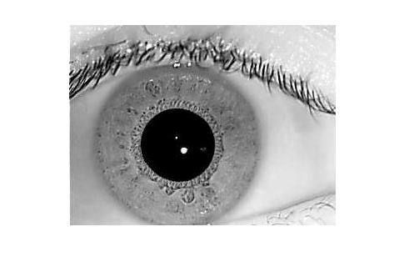
Fig 5.1.1: Loading image(sample image 1)

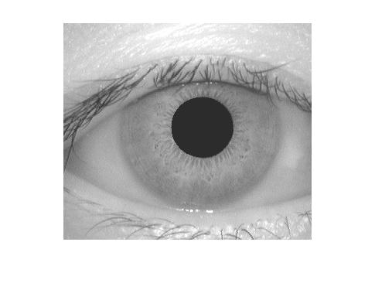
Fig 5.1.2: Loading image(sample image 2)

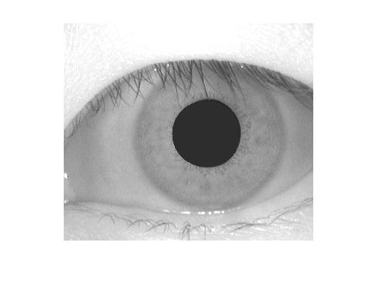
Fig 5.1.3: Loading image(sample image 3)

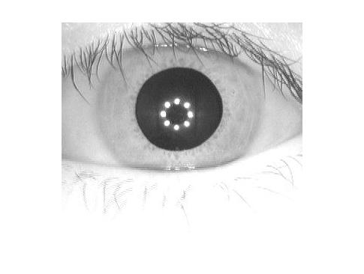
Fig 5.1.4: Loading image(sample image 4)

5.2 Preprocessing of image

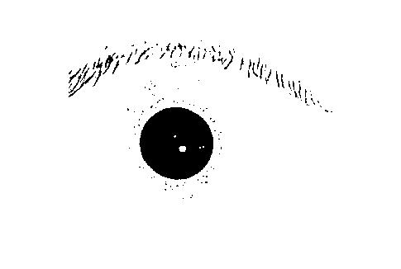
Fig 5.2.1: Preprocessing (sample image 1)

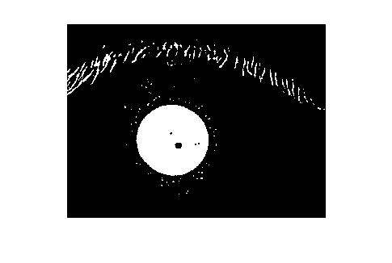
Fig 5.2.2: Inversion (sample image 1)


Fig 5.2.3: Preprocessing (sample image 2)

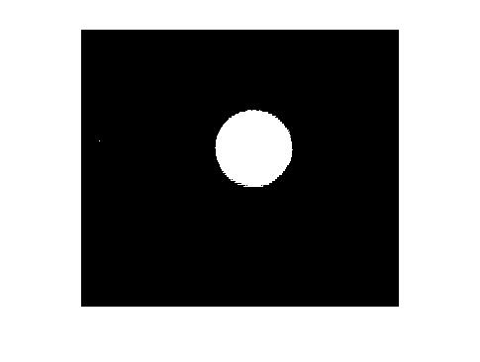
Fig 5.2.4: Inversion (sample image 2)


Fig 5.2.5: Preprocessing(sample image 3)


Fig 5.2.6: Inversion (sample image 3)


Fig 5.2.7: Preprocessing(sample image 4)

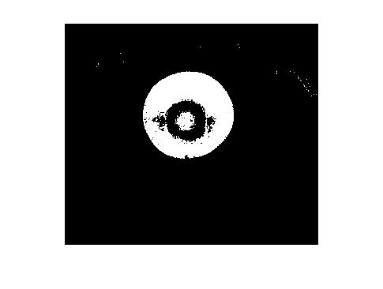
Fig 5.2.8: Inversion (sample image 4)

5.3 Localisation (John Daugman’s algorithm)
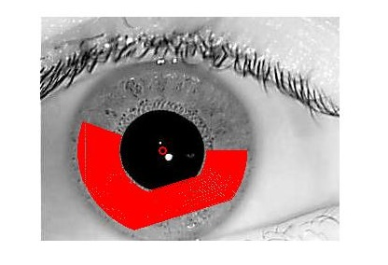
Fig 5.3.1: Localisation (sample image 1)

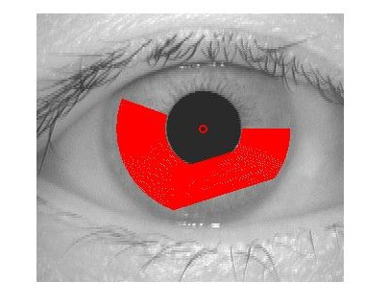
Fig 5.3.2: Localisation (sample image 2)

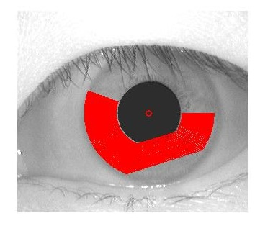
Fig 5.3.3: Localisation (sample image 3)

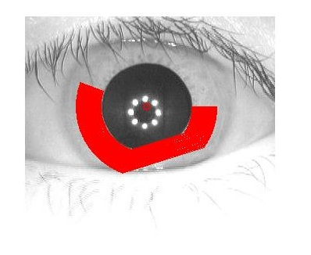
Fig 5.3.4: Localisation (sample image 4)

5.4 Normalisation (Rubber sheet model)
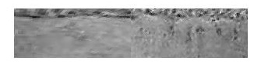
Fig 5.4.1: Normalisation (sample image 1)

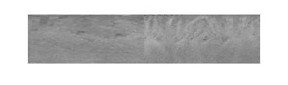
Fig 5.4.2: Normalisation (sample image 2)


Fig 5.4.3: Normalisation (sample image 3)
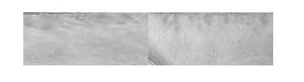
Fig 5.4.4: Normalisation (sample image 4)

CHAPTER 7
FUTURE SCOPE OF THE PROJECT
6.1 Some Future Applications of Iris Recognition
- National border controls: Iris is one of three biometric identification technologies internationally standardized by ICAO for use in future passports (the other two are fingerprint and face recognition).
- Computer login: The iris as a living password reduces the possibility of hacking the computer system.
- Cell phone and other wireless-device-based authentication.
- Secure access to bank accounts at cash machines.
- Ticketless travel and authentication of rights to services are also possible with this technology.
- Premises access control: Premises like home, office, laboratory, etc can be accessed only by the authorized people.
- In Driving licenses and other personal certificates.
- In Forensics, birth certificates and tracing missing or wanted persons iris recognition has a wide scope.
- Credit-card authentication can be achieved using this system.
- Automobile ignition and unlocking & anti-theft devices.
- Anti-terrorism (e.g. security screening at airports).
- Secure financial transactions (electronic commerce, banking).
- Internet security and control of access to privileged information.
- Iris recognition system can be used in any existing use of keys, cards, PINs, or passwords.

6.2 Some Deployed Applications
- United Arab Emirates IrisGuard's Homeland Security Border Control has been operating an expellee tracking system in the United Arab Emirates (UAE) since 2001, when the UAE launched a national border-crossing security initiative. Today, all of the UAE's land, air and sea ports of entry are equipped with systems. All foreign nationals who possess a visa to enter the UAE are processed through iris cameras installed at all primary and auxiliary immigration inspection points. To date, the system has apprehended over 330,000 persons re-entering the UAE with fraudulent travel documents.
- Aadhaar, India's Unique ID project for its one billion citizens uses Iris scan as one of the identification features.
- Police forces across America planned to start using BI2 Technologies' mobile MORIS (Mobile Offender Recognition and Information System) in 2012. New York City Police Department was the first, installed in Manhattan fall of 2010.
- Iris recognition technology has been implemented by BioID Technologies SA in Pakistan for UNHCR repatriation project to control aid distribution for Afghan refugees. Refugees are repatriated by UNHCR in cooperation with Government of Pakistan, and they are paid for their travel. To make sure people do not get paid more than once, their irises are scanned, and the system will detect the refugees on next attempt. The database has more than 1.3 million iris code templates and around 4000 registrations per day. The one-to-many iris comparison takes place within 1.5 seconds against 1.3 million iris codes.
- At Amsterdam Airport Schiphol, Netherlands, iris recognition has permitted passport-free immigration since 2001.
- Canadian Air Transport Security Authority's Restricted Area Identity Card (RAIC) program is the world's first dual-biometric program deployed around major Canadian airports for staff and aircrews to access the restricted areas using separate channels from passengers.
- In several Canadian airports, as part of the CANPASS Air program that facilitates entry into Canada for pre-approved, low-risk air travelers.

APPENDIX
MATLAB CODE OF IRIS RECOGNITION SYSTEM

%%
%Section 1
%Extracting pupil from the given image
clc
clear all
close all
a=(imread('6.bmp'));
[r,c,w]=size(a);
if w==3
a=rgb2gray(a);
end
a1=im2bw(a,0.2);

% a1=im2bw(a,0.1);
%
% a1=im2bw(a,0.05);

a2=~a1;
imshow(a2)
%%
%Section 2
%Removing the noise
ab=bwareaopen(a2,200); %%removes all the connected components that have area lesser than 200 pixels
close all
s=strel('disk',2);
ab=imdilate(ab,s);
af=imfill(ab,'holes');
figure,imshow(af)
%end
close all
af=imclearborder(af);
imshow(af)
%%
%Section 3
%Getting properties of the pupil region.
reg=regionprops(af,'all');
center=reg.Centroid;
close all
hold on

%alpha(0.5);
imshow(a);
%as=@(x) imadjust(x,[],[],0.3);
%aj=roifilt2(a(:,:,1),af,as);
%hold on
%close all
%imshow(aj)
% alpha(0.5)
shg
%%
%Section 4
%Daugman rubbersheet model
[B,L]=bwboundaries(af);
b=B{1};

d=sqrt((center(1)-b(1,2))^2+(center(2)-b(1,1))^2) %finding the distance between the center of the pupil and its boundaries.

theta=[linspace(-35,35,150) linspace(110,200,150)];
%theta=linspace(110,200,150);
% x=center(1)+d*cos(theta);
% y=center(2)+d*sin(theta);
%
% d2=90;
%
% x1=center(1)+d2*cos(theta);
% y1=center(2)+d2*sin(theta);
% axa=a(:,:,1);
d2=90;
imshow(a)
hold on
%plot(x,y,'linewidth',2)
%plot(b(:,2),b(:,1),'g')
%shg
plot(center(1),center(2),'ro','linewidth',2)

final=0;
rad=linspace(d,d2,64);
[r,c]=size(a);
for i=1:length(rad);
xa(i,:)=round(center(1)+rad(i)*cosd(theta));
ya(i,:)=round(center(2)+rad(i)*sind(theta));
plot(xa(i,:),ya(i,:),'r');
for j=1:length(theta);
if ya(i,j)<=r && xa(i,j)<c
final(i,j)=a((ya(i,j)),(xa(i,j)));
end
end
pause(0.01);
end
impixelinfo
% finalj=x2(round(x),(y));

figure,imshow(uint8(final))
impixelinfo

[Ah6 Av6]=codingeye(final);
% figure(6),imagesc((Av))
save('Ahh6','Ah6');
save('Avv6','Av6');
TO CALCULATE THE HAMMING DISTANCE

clc
clear all
close all
load Ah6
load Av6

load Ahnew
load Avnew

[r,c]=size(Ahnew);
N=r*c;
Hd=1/(2*N)*(sum(sum(xor(Ahnew,Ah6)))+sum(sum(xor(Avnew,Av6))))

if Hd<=0.0032
disp('detected');
else
disp('not detected');
end;

REFERENCES

[1] CASIA iris image database,Chinese Academy of Sciences Institute of Automation.

[2] J. Daugman “How iris recognition works”, Proceedings of 2002 International Conference

[3] L. Masek , “Recognition of Human Iris Patterns for Biometric Identification”,
Master
thesis, University of Western Australia, 2003.

[4] John Daugman, Professor of Computer Vision and Pattern Recognition

http://www.cl.cam.ac.uk/~jgd1000/

[5] Introduction to Iris Recognition

http://www.cl.cam.ac.uk/~jgd1000/iris_recognition.html

